

**Project Part 1**

**Topic**

Exploring Cultural Representation and anxiety in Video Games: The Impact of Cultural Elements on Player anxiety Levels and Engagement

1. A short summary (1/2 page to 1 page) of:
   1. Your interests:

I am interested in AI,ML and NLP, especially in tackling complex computational problems. My focus extends to predictive maintenance, interactive software development, and data-driven applications, all of which guides my educational goals. I also love gaming and was an esports athlete back in India.

* 1. The reasons why you choose your current degree and major:

Pursuing a Master’s in CS allows me to deepen my knowledge in AI and NLP, enhancing my capability to design impactful solutions. This degree builds on my prior computer science studies and aligns with my love and passion for innovative and user friendly applications for users on a large scale. I would love to work on crosslist teams including product and engineering teams in the upcoming future.

* 1. The reasons why you decided to take this class:

The class offers skills in experimental design and ethics, equipping me to effectively analyze user engagement and ensure ethical research standards—skills essential for research.

* 1. Your personal ambitions to change the world:

I aim to contribute to AI tools that promote global knowledge sharing and accessibility, fostering inclusivity across cultures and demographics. My work focuses on bridging informational gaps and designing impactful, approachable technologies for a more connected world.

* 1. The reasons why you are interested in the topic you have chosen for your project:

This project examines how cultural elements influence player anxiety and engagement. This study aligns with my interest in AI and data analysis, as I seek to understand how game design can affect player experiences, paving the way for more inclusive gaming environments.

* 1. Show me a screenshot of your CITI certification for human subjects research.

[Link for Screenshot](https://drive.google.com/file/d/1bVmznaVSwv3dKu4_MW54JZop8XPalyNn/view?usp=drive_link) (<https://drive.google.com/file/d/1bVmznaVSwv3dKu4_MW54JZop8XPalyNn/view?usp=drive_link>)

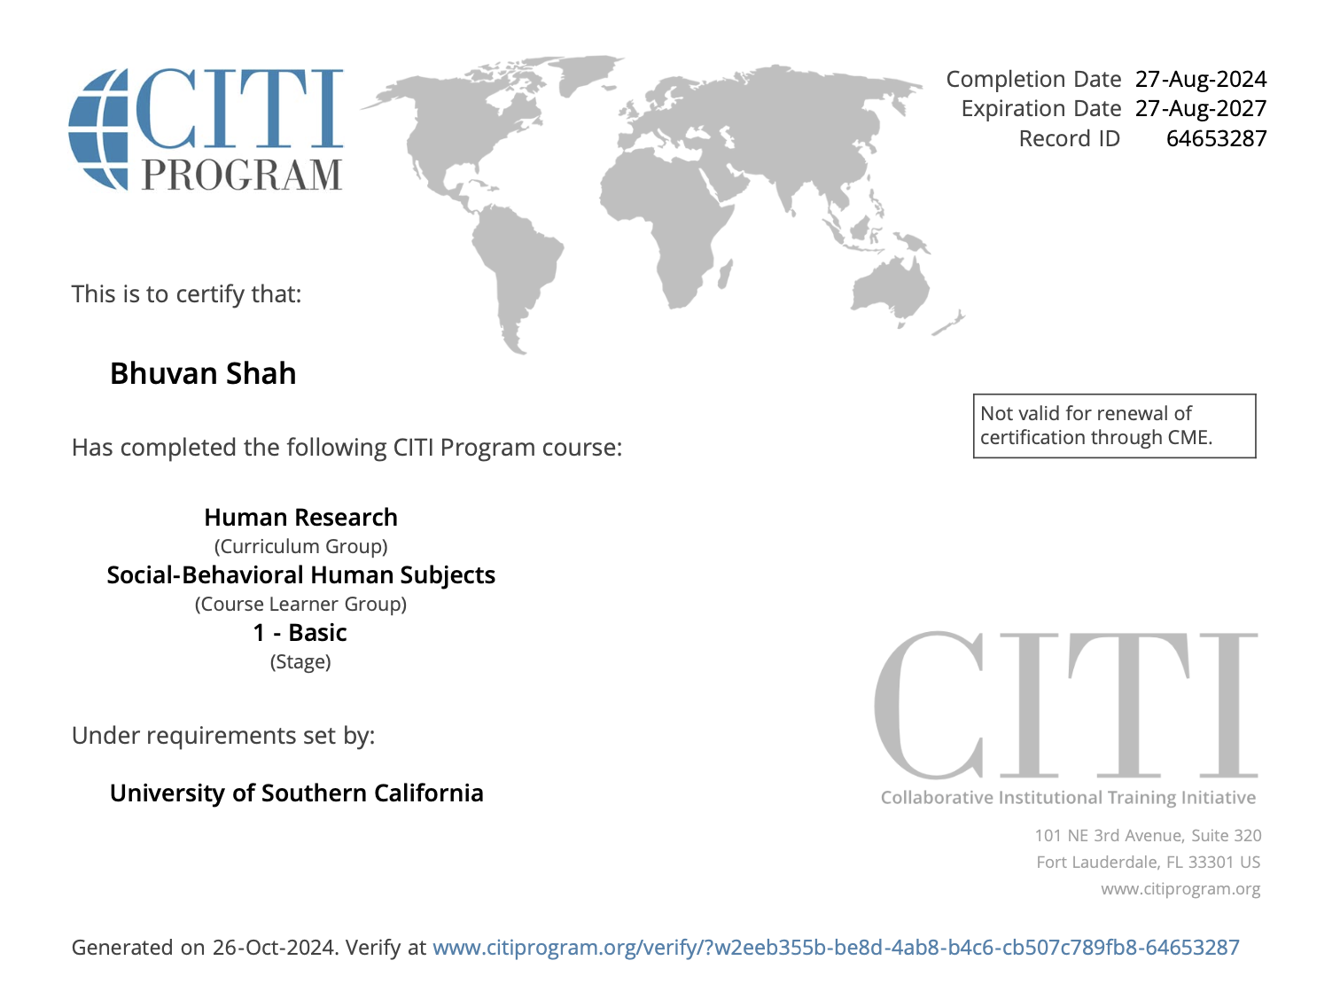

1. Sketch out the plan for the user study that you will conduct this term, including details such as:
   1. What variables are you going to collect?

We plan to collect the following variables:

**1**. **Demographic Variables(**Age, Gender,Identity, Nationality, Cultural, Background**)**

**2**. **Game-Related Variables(**Number of Games PlayedTime Spent Gaming Per Week,Whether participants play or watch esports tournaments**)**

**3. anxiety Variables(**Before and After Session State anxiety Levels**)**

**4. Cultural/Commonality Variables(**Cultural Influence on Engagement, Comparative Preference, Cultural Relevance**)**

**5. Personality Traits(**Brief Big Five Inventory**)**

* 1. What design is your study (experimental vs. correlational, if experimental, what factors are between subjects vs. within subjects)?

Our study uses an **experimental design**, manipulating exposure to an Indian (maybe Chinese as well) cultural video game to evaluate its impact on anxiety. It follows a **within-subjects** approach, measuring participants before and after exposure to control individual differences effectively.

* 1. Given those answers, out of those variables which are your IV(s) and DV(s)?

**Independent Variables (IVs):**

| 1. Age | **6.** Time Spent Gaming Per Week |
| --- | --- |
| 1. Gender Identity | **7.** Engagement with Esports (Playing/Watching) |
| 1. Nationality | **8.** Pre-Session State anxiety Level |
| **4.** Cultural Background | **9.** Cultural Relevance |
| **5.** Types of Games Played | **10**. Personality Traits (Brief Big Five Inventory) |

**Dependent Variable (DV):**

| Post-Session State anxiety Levels | Comparative Preference | Cultural Influence on Engagement |
| --- | --- | --- |

* 1. What are the operational definitions going to be for your IV(s) and DV(s)? (ie how are you going to measure or manipulate the variables)?

#### Independent Variables (IVs):

1. **Demographic Variables (Age, Gender, Nationality, Cultural Background)**:
   * **Operational Definition**: Collected through self-reported survey data. Age will be measured in years, gender identity and nationality through a multiple-choice format, and cultural background will involve a self-reported identification of ethnicity or cultural heritage.
2. **Game-Related Variables (Number of Games Played, Time Spent Gaming, Esports Participation)**:
   * **Operational Definition**: Measured through a questionnaire where participants select the number of games they play, estimate the hours spent gaming per week, and indicate whether they participate in or watch esports.
3. **Personality Traits**:
   * **Operational Definition**: Measured using the **Brief Big Five Inventory**, where participants will rate themselves on a scale across the five dimensions of personality (Openness, Conscientiousness, Extraversion, Agreeableness, Neuroticism).
4. **Pre-Session State anxiety**:
   * **Operational Definition**: Measured using a standardized anxiety scale (e.g., the [**State-Trait anxiety Inventory**](https://brieflands.com/articles/aapm-130790/supplementary-material/aapm-130790-Supplementary%20File.pdf)) before exposure to the cultural video game. Participants will rate their anxiety level based on a Likert scale.
5. **Cultural Relevance**:
   * **Operational Definition**: Measured by asking participants to rate the degree to which they feel the game represents elements of their culture, using a Likert scale.

#### Dependent Variables (DVs):

1. **Post-Session State anxiety**:
   * **Operational Definition**: Measured using the same standardized anxiety scale as pre-session, but administered after exposure to the video game to assess changes in anxiety levels.
2. **Comparative Preference**:
   * **Operational Definition**: Participants will rate their preference for the culturally relevant video game compared to non-culturally relevant games, using a Likert scale.
3. **Cultural Influence on Engagement**:
   * **Operational Definition**: Measured by asking participants to rate their level of engagement and connection with the video game, specifically in relation to its cultural elements, using a Likert scale.

* 1. What is your population? How are you going to get participants from that population? How many are you planning to recruit for the study?

Population: Our target population includes the general public, with a specific emphasis on individuals who engage in gaming to provide a more informed perspective.

Recruitment: Recruitment will focus primarily on students from the CSCI 526 (Advance Game Development) class, in addition to broader outreach efforts to gather diverse participants.

Sample Size: We aim to recruit a minimum of 25 participants per cultural group, ensuring adequate statistical power. Overall, we anticipate a total sample size of 40-50 participants, contingent on the demographic distribution.

1. Sketch out your plan for analysis:
   1. State your research question(s), and discuss how it could be answered by analyzing the data that you listed in the previous question. That is, affirm for me that your research question is answerable using the data you will collect.

Ans:

Our research question is: "How do cultural elements in video games impact players' anxiety levels and engagement, specifically when they share cultural similarities?"

To address this, we will:

**i. Compare anxiety Levels (State anxiety Before and After Exposure)**

By collecting pre- and post-session anxiety levels, we can assess whether culturally specific games reduce anxiety for players with matching cultural backgrounds.

**ii. Measure Engagement and Cultural Connection**

We will assess engagement levels, perceived cultural connection, and preference for culturally relevant games. This will help us determine if players feel more engaged when they identify culturally with the game.

**iii. Analyze Demographic and Personality Data**

Demographic and personality data will allow us to examine whether specific traits or backgrounds correlate with changes in anxiety and engagement.

By analyzing these data points, we can establish connections between cultural representation in games, anxiety reduction, and player engagement, making our research question answerable through the collected variables.

* 1. Describe in your own words what kinds of analysis could be done with the data to answer each question. Be specific about what analysis -within null hypothesis significance testing- you would use and why.

**Comparing Pre- and Post-Session anxiety**:

* **Analysis**: Paired t-test.
* **Why**: To test for significant differences in anxiety before and after exposure. Null hypothesis: No change in anxiety levels.

**Cultural Influence on Engagement**:

* **Analysis**: Pearson correlation.
* **Why**: To assess the relationship between cultural relevance and engagement. Null hypothesis: No correlation.

**Demographic Effects on anxiety and Engagement**:

* **Analysis**: One-way ANOVA.
* **Why**: To check for differences across demographic groups. Null hypothesis: No significant group differences.

**Personality Traits and anxiety Reduction**:

* **Analysis**: Multiple regression.
* **Why**: To predict anxiety reduction based on personality traits. Null hypothesis: Personality traits don’t predict anxiety change.

**Cultural Background and Game Preference**:

* **Analysis**: Chi-square test.
* **Why**: To check for association between cultural background and game preference. Null hypothesis: No association.